
World Book Day Celebrations at Eastcourt
March 7th 2019

World Book Day is an annual event which aims to focus our attention on books, often in different and unusual ways. It also raises funds for children in other parts of the world where they are less fortunate than we are and do not have books automatically available.

As usual, we have a range of competitions for all the children, hopefully something to appeal to everyone.

You can enter as many or few competitions as you want, making a donation of £1 for each entry. All profits will go to Book Aid International, an organisation which exists to encourage literacy and access to books. There are two age groups – Reception + Infants, and Juniors. All entrants are invited to our celebration at 11am on Thursday, March 7th.

The Competitions

Who? These competitions look at characters.

- Guess Who?
Decide who you want to be for the day – a character from a children’s book. Write 25-50 words about your choice, to be brought to your class teacher on Thursday March 7th. Dress as your character. Can Mr Babra and Mrs Binu (for KS2), or Mrs Carey-Jones and Miss Redgrave (for KS1) guess who you are?

Where? Another important decision for budding authors. These next competitions target settings.

- Peg Doll Competition
Have a look at our Peg Doll Page!
These characters have been designed by our children. Choose one of them. Can you describe where he or she lives? KS1 maximum 35 words, judged by Mrs Smith and Mrs Ghafoor; Juniors 75 words, judged by Mrs Redgrave and Mr Barnard. Make sure you write clearly what number you have chosen.
The Peg Doll Page!

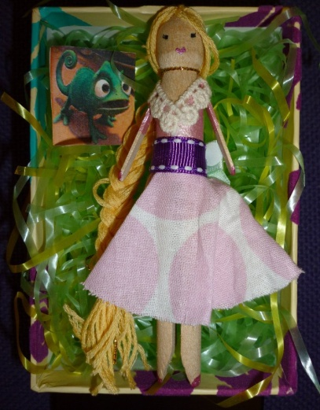 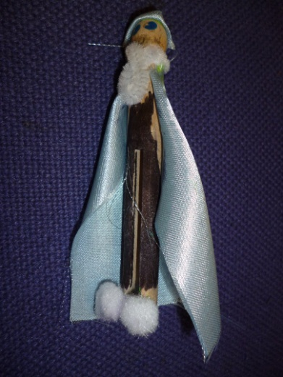 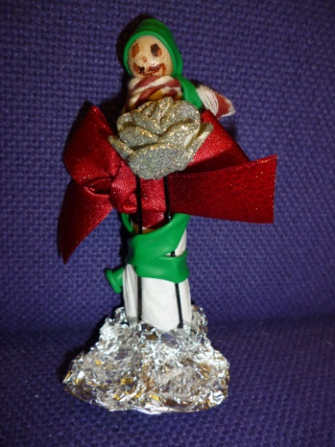
1. 2. 3.

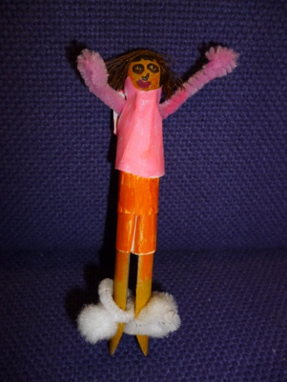
4.

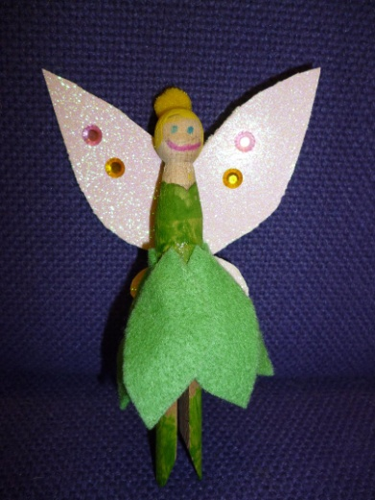 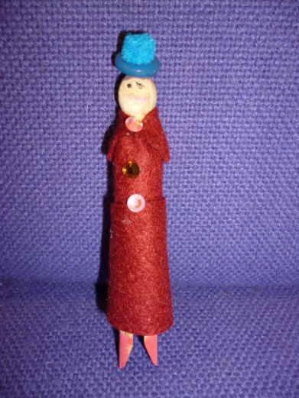 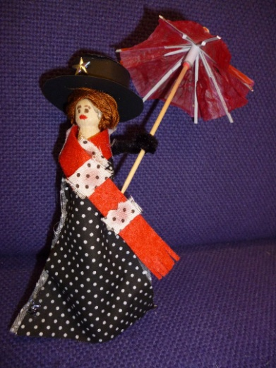
5. 6. 7.
How did it end? Those final sentences make or break a good story! Competition 3. In this competition we give you six options for each of character, setting and plot. Choose one from each column, and make up an ending for a story which involves all three.

Characters Setting Plot

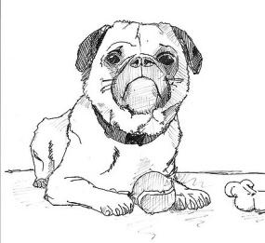


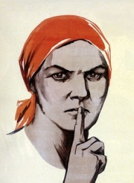



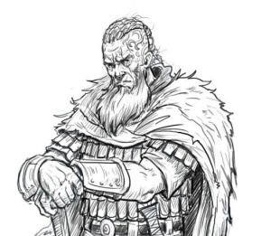



Indoors: your house

Outdoors: a city

Indoors: a school

Outdoors: a beach

Indoors: a shop

Outdoors: a wood

There’s danger, but they don’t know what it is. They make plans to avoid it, but one of them disagrees. It comes. What do they do?

You are in charge, and they all look to you for what to do. Trouble is, you aren’t sure – all options have serious drawbacks. You have to make a decision – now!

There’s been an argument. You did not do it, and you know perfectly well who did. You did not mean to sound rude, but that’s the way it came out. Do you tell them who did it?

It’s time to go out, but one wants to walk (healthier), the other to use the car (quicker). You don’t mind which, so long as you don’t have to stay in. But now they’re arguing. What can you do?

It wasn’t supposed to end like this. Was it something you said? Why can’t people be more reasonable? If only we could go back to yesterday... now what will happen?

There’s no-one there – they’ve all disappeared. The place is empty. It’s happened at last, but you’re still there. There must be someone else left – mustn’t there?
KS1 children are allowed up to 50 words, KS2 children 75-100. (You don’t need to give us the whole story – just your own ending.) Your judges will be Miss Lawford and Miss Hayward (KS1), and Ms Hunswick and Miss Gilbert (KS2).

Cakes Around the World
Competition 4.
Books are sent to children around the world. Our family challenge is for you to design and make a cake connected to a particular country – perhaps a famous landmark, a traditional dress or food, the flag or shape of the country itself. The winning entry will receive a prize and the cakes will be given as raffle prizes following the coffee morning. Please bring your entries to school on Wednesday March 6th in a sealed container, or early on World Book Day for judging.

Our judges are Mrs Kail, Mrs Kalsi and Mrs Adkins.

_______________

Book Bring and Buy and Coffee Morning

Mrs Smith and Mrs Ghafoor will be collecting for our Bring and Buy sale this year. They need books in good condition which you no longer want.

Bring your unwanted books in at any time up until the morning of World Book Day.

Buy anything you like (prices from 20p) in the hall on World Book Day. Enjoy a drink and a biscuit/cake too! (All donations of cakes/biscuits also welcome.)

_______________

Don’t forget to include your Competition Slip and £1 donation for each entry when you submit your writing (and your cooking!)
Eastcourt World Book Day Entry Form
Competition 1: Guess Who? Infant
.................................................................................................. .Junior [tick applicable]
Name:_____________________________________

I enclose my £1 entry fee(s) for this competition.

Eastcourt World Book Day Entry Form
Competition 2: The Peg Doll Infant
................................................................................................... Junior [tick applicable]
Name:_____________________________________

I enclose my £1 entry fee(s) for this competition.

Eastcourt World Book Day Entry Form
Competition 3: How Did It End? Infant
................................................................................................... Junior [tick applicable]
Name:_____________________________________

I enclose my £1 entry fee(s) for this competition.

Eastcourt World Book Day Entry Form
Competition 4: Cakes Around the World Infant
................................................................................................... Junior [tick applicable]
Name:____________________________________

I enclose my £1 entry fee(s) for this competition.

